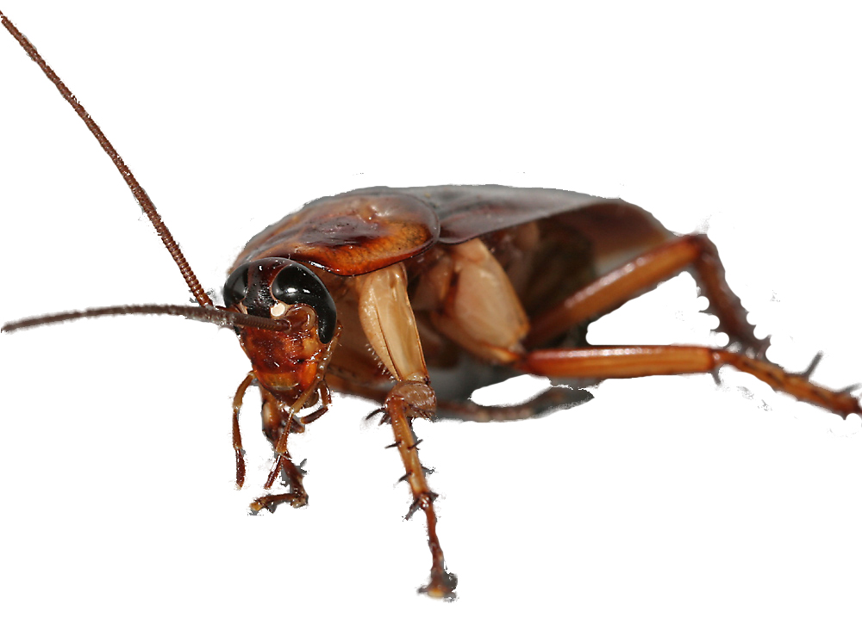
Do these things daily:
Clean and dry all dishes—no food out at night
Put all food in sealed containers or the refrigerator
Take the trash out
Wipe down the counters and stove
Sweep the floor
Do these things weekly:
Vacuum carpeted floors
Recycle bottles, cans, and cardboard
Do a load of laundry
Inspect your home for pests

Working together towards pest-free housing.
- Residents: keep pests from getting food, water, and shelter.
- Resident Services: help residents learn how to do their part and get support.
- Maintenance: fixes holes that let pests in.
- Pest Control: monitors for pests and applies pesticides.
- Management: makes sure everyone is doing his or her part to keep our building pest-free.
Brought to you by the
Development Name Management Office and
The Regional IPM Centers
To place a work order, call:
000-0000

What’s wrong with my housekeeping?

To live happily pests need
- food,
- water, and
- a place to hide.
Make sure they don’t get what they need.

Integrated Pest Management (IPM) at PHA
Your role in pest control
You don’t have to live with pests.
Insert Development-Specific Photo
TEMPLATE: Rev. 12/11
Download at www.stoppests.org

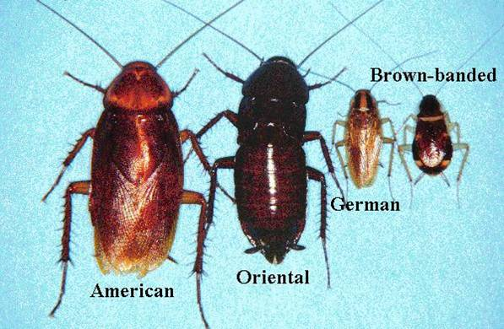
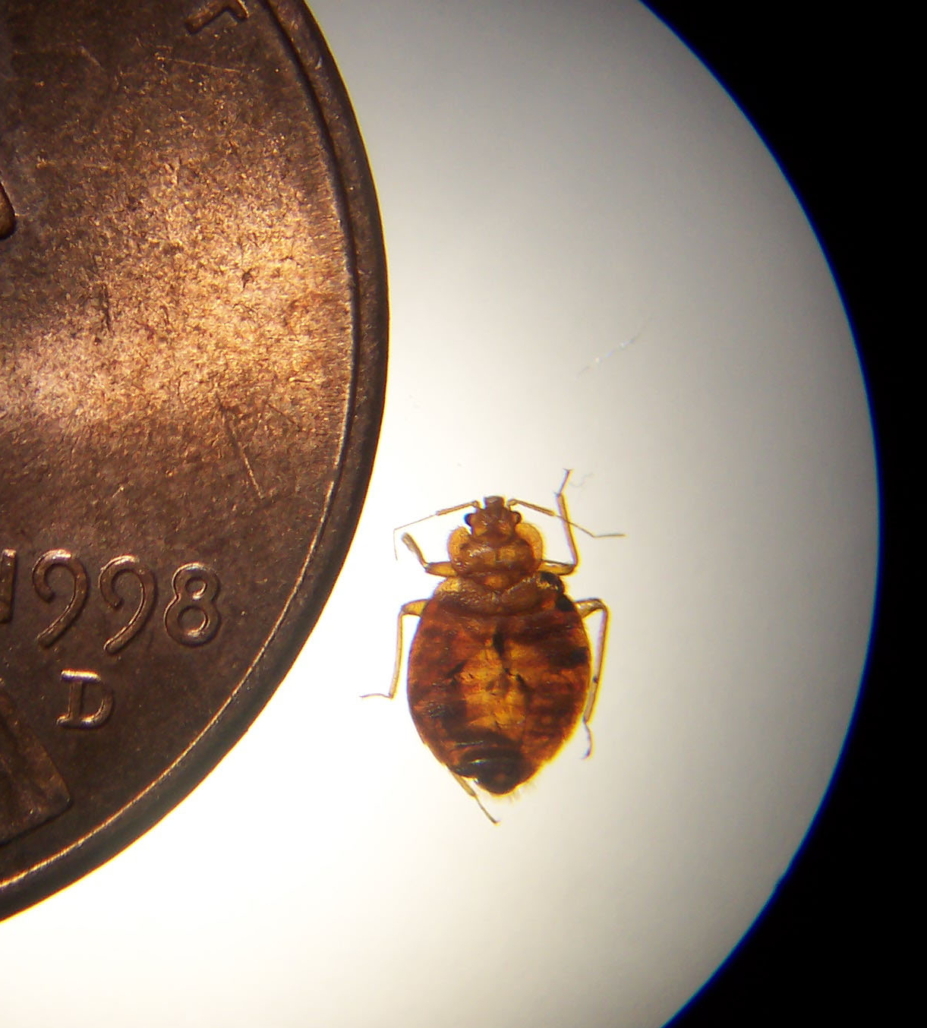
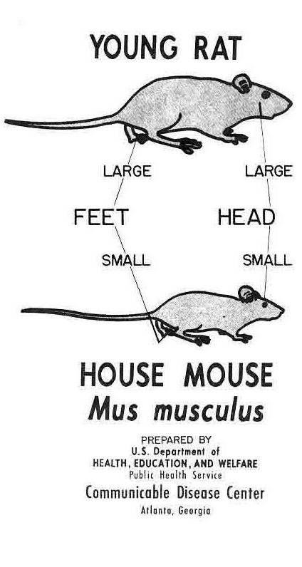
What you can do to kill pests:
Trap them and throw them away.
Vacuum them up (seal the bag in a plastic bag and put it in the trash).
Focus your efforts on housekeeping.
Call 000-0000 to get a professional to apply pesticides— don’t use your own!
What you can do to keep your home pest free:
Clean up crumbs and spills.
Take out trash and recycling regularly.
De-clutter! Limit the amount of unused stuff you store in your home. Clutter gives pests a place to hide.
Be wary of used furniture—it might have bed bugs.
Store food where pests can’t get to it.
Vacuum, sweep, and mop the floors.
Report leaking faucets and clogged drains.
Help us get free services to you.
If you see:
A cockroach, mouse, rat or bed bug;
Signs that these pests have been around;
A place where pests can get into your home; or
A leaky pipe.
Call in a work order :
000-0000
Do not use sprays or foggers (bug bombs) in your home.

Cockroaches are health hazards!
Even the dead ones can make asthma worse in sensitive people and cause asthma in preschool-aged children!

Got pests?
PHA will help.
Bed Bug

Cockroaches

“………………..”
~ add a quote about pest-free housing from someone in management

